Day 82

DIY

DIY Questions

1.How to deploy redis application provided pods are running on each node of the cluster?

Answer:

sudo nano daemonset.yaml

apiVersion: apps/v1

kind: DaemonSet

metadata:

name: redis-daemonset

spec:

template:

metadata:

labels:

app: redis

spec:

containers:

- name: redis-container

image: redis:latest

selector:

matchLabels:

app: redis

kubectl explain ds

kubectl create -f daemonset.yaml

kubectl get ds (daemonset)

kubectl get po

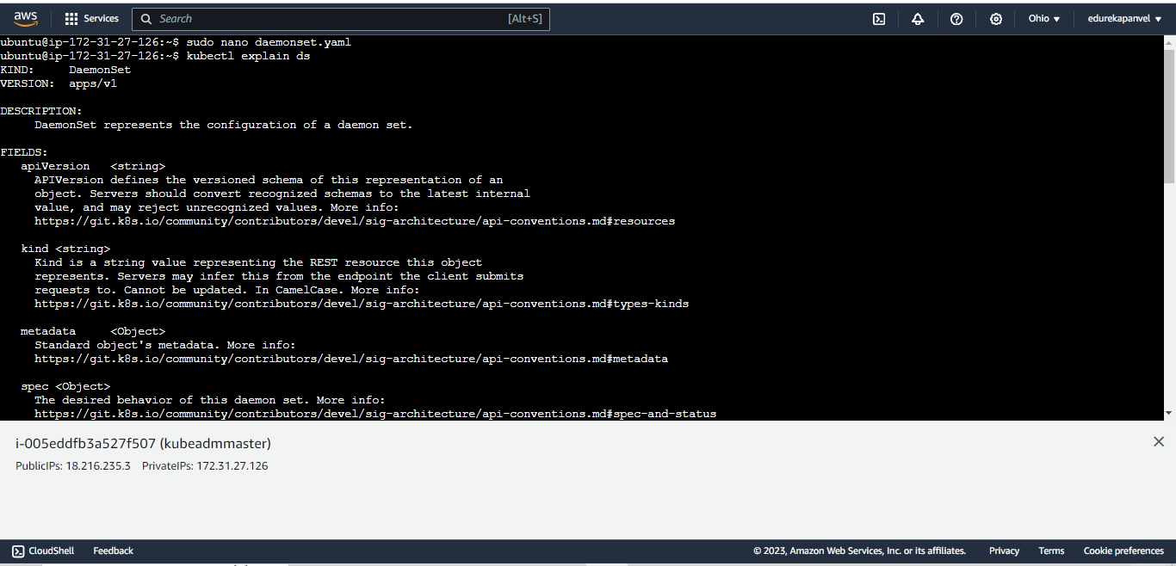

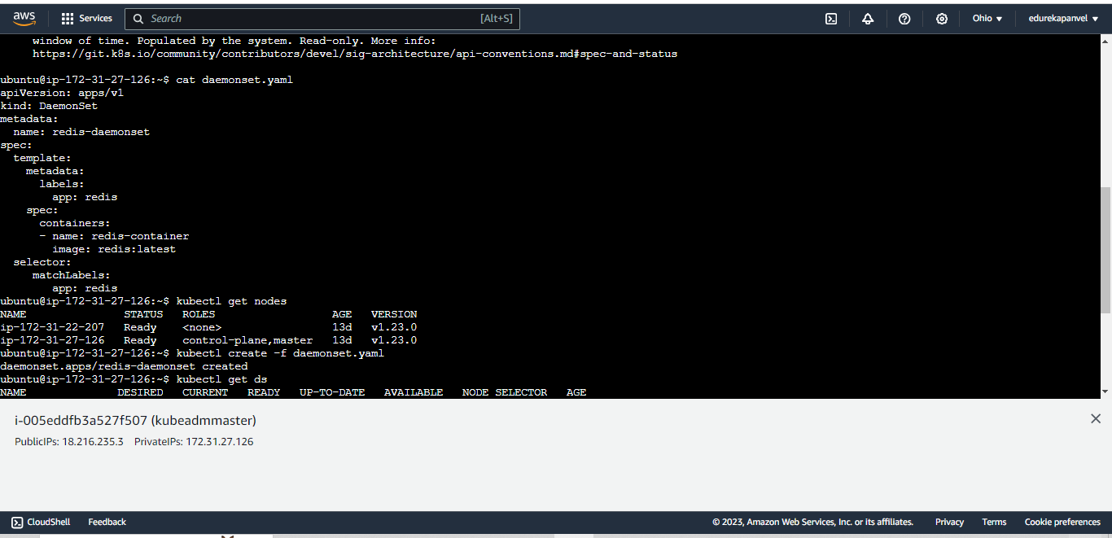

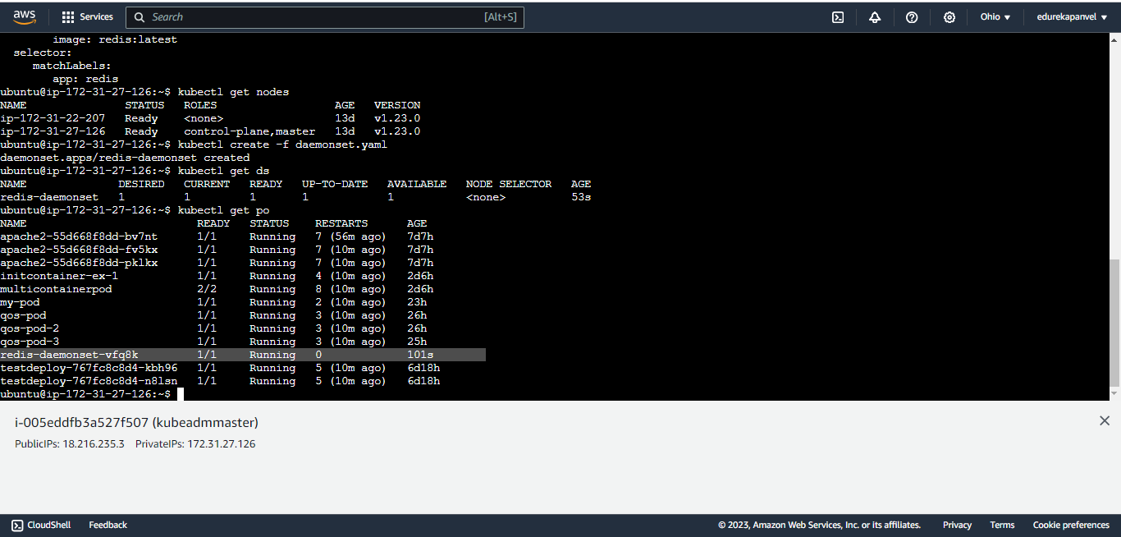

2.Which of the following is not an access mode for PV

a)Read-write Once

b)Read-write Many

c)Read only Many

d)Read only Once

Answer:

**d)Read only Once**

3.Which of the following statement is correct about persistent volumes?

a)PV can be utilized as cluster resource

b)Kubernetes binds the PVC to the best possible PV

c)PV provides stability required for stateful and distributed applications

d)All of the above

Answer:

**d)All of the above**

4.Persistent storage is best suited for what type of applications?

a)Stateful applications

b)Stateless applications

c)Both a and b

d)None of the above

Answer:

**a)Stateful applications**

5.How to create a PV of size 1 GB using standard storage class?

Answer:

Create storage.yaml which will rete storage volume for your pv

sudo nano storage.yaml

apiVersion: storage.k8s.io/v1

kind: StorageClass

metadata:

name: standard

provisioner: kubernetes.io/aws-ebs

parameters:

type: gp2 # Use the appropriate EBS volume type

Now create pvc.yaml file

apiVersion: v1

kind: PersistentVolume

metadata:

name: testpvc

spec:

accessModes:

- ReadWriteOnce

Resources:

Requests:

storage: 1Gi

storageClassName: standard

--- kubectl create –f pvc.yaml

--kubectl get pvc

Now create the pod to use this volume

Create pod.yaml

sudo nano pod.yaml

apiVersion: v1

kind: Pod

metadata:

name: pod-pvc

spec:

containers:

- name: myfrontend

image: nginx

volumeMounts:

- mountPath: /var/www/html

name: mypd

volumes:

- name: mypd

persistentVolumeClaim:

claimName: testpvc

6.How to create a pod with nginx container and mount the above-created volume in the container on path /var/www/html?

Answer:

Now create the pod to use this volume

Create pod.yaml

sudo nano pod.yaml

apiVersion: v1

kind: Pod

metadata:

name: pod-pvc

spec:

containers:

- name: myfrontend

image: nginx

volumeMounts:

- mountPath: /var/www/html

name: mypd

volumes:

- name: mypd

persistentVolumeClaim:

claimName: testpvc